**Optimizing Flight Booking Decisions through Machine Learning Price Predictions**

**INTRODUCTION:**

**Overview**

People who work frequently travel through flight will have better knowledge on best discount and right time to buy the ticket. For the business purpose many airline companies change prices according to the seasons or time duration. They will increase the price when people travel more. Estimating the highest prices of the airlines data for the route is collected with features such as Duration, Source, Destination, Arrival and Departure. Features are taken from chosen dataset and in the price wherein the airline price ticket costs vary overtime. we have implemented flight price prediction for users by using KNN, decision tree and random forest algorithms. Random Forest shows the best accuracy of 80% for predicting the flight price. also, we have done correlation tests and metrics for the statistical analysis.

**Purpose**

To determine ideal purchase time for flight ticket. There project aims to develop an application which will predict the flight prices for various flights using machine learning model. The techniques they have used are mentioned as Linear Regression, Decision Tree and random Forest.

What can be achieved using this?

Machine Learning algorithms are applied on the dataset to predict the dynamic fare of flights. This gives the predicted values of flight fare to get a flight ticket at minimum cost. Data is collected from the websites which sell the flight tickets so only limited information can be accessed.

**Problem Definition & Design Thinking**

**Empathy Map**

An **empathy map** is a collaborative visualization used to articulate what we know about a particular type of user. It externalizes knowledge about users in order to 1) create a shared understanding of user needs, and 2) aid in decision making.

This article is a guide to empathy mapping and its uses.

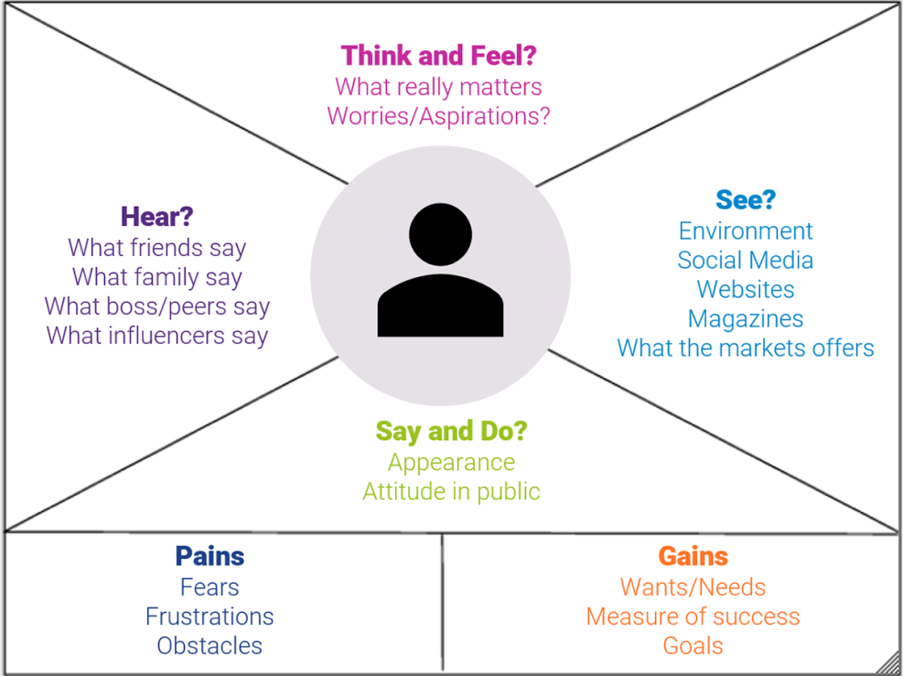

Define scope and goals

a. What user or persona will you map? Will you map a persona or an individual user? Always start with a 1:1 mapping (1 user/persona per empathy map). This means that, if you have multiple personas, there should be an empathy map for each.

b. Define your primary purpose for empathy mapping. Is it to align the team on your user? If so, be sure everyone is present during the empathy-mapping activity. Is it to analyze an interview transcript? If so, set a clear scope and timebox your effort to ensure you have time to map multiple user interviews.

2. Gather materials

Your purpose should dictate the medium you use to create an empathy map. If you will be working with an entire team, have a large whiteboard, sticky notes, and markers readily available. (The outcome will look somewhat like the illustration above.) If empathy mapping alone, create a system that works for you. The easier to share out with the rest of the team, the better.

3. Collect research

Gather the research you will be using to fuel your empathy map. Empathy mapping is a qualitative method, so you will need qualitative inputs: user interviews, field studies, diary studies, listening sessions, or qualitative surveys.

4. Individually generate sticky notes for each quadrant

Once you have research inputs, you can proceed to mapping as a team. In the beginning, everybody should read through the research individually. As each team member digests the data, they can fill out sticky notes that align to the four quadrants. Next, team members can add their notes to the map on the whiteboard.

5. Converge to cluster and synthesize

In this step, the team moves through the stickies on the board collaboratively and clusters similar notes that belong to the same quadrant. Name your clusters with themes that represent each group (for example, “validation from others” or “research”). Repeat themes in each quadrant if necessary. The activity of clustering

facilitates discussion and alignment — the goal being to arrive at a shared understanding of your user by all team members.

Once your empathy map is clustered, you can begin to vocalize and align as a team on your findings. What outliers (or data points that did not fit in any cluster) are there? What themes were repeated in all the quadrants? What themes only exist in one quadrant? What gaps exist in our understanding?

6. Polish and plan

If you feel that you need more detail or you have unique needs, adapt the map by including additional quadrants (like Goals the example below) or by increasing specificity to existing quadrants. Depending on the purpose of your empathy map, polish and digitize the output accordingly. Be sure to include the user, any outstanding questions, the date and version number. Plan to circle back to the empathy map as more research is gathered or to guide UX decisions.

**Ideation & Brainstorming Map**

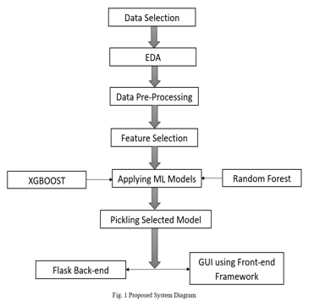

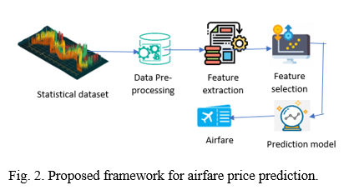

**RESULT:**

Flight booking engine will display the result with flight details like, Airline Name, Airline Logo, Departure Airport Details, Departure Terminal, Arrival Airport Details, Arrival Terminal, Travel Time, Amount, Fare Rules, Flight Details, Seat Map, Sorting option on Airline Name, Departure Time, Arrival Time and Price, System will display the result from all the sources without any differentiation.

ADVANTAGES & DISADVANTAGES